#
# 20191120
#
From: Bukovnya Sergey Nikolaevich <s.bukovnya@tinkoff.ru>
Sent: Wednesday, November 20, 2019 10:13 AM
To: Mogilevskiy Kirill Dmitrievich <k.mogilevskiy@tinkoff.ru>; unix-admins <unix-admins@tinkoff.ru>
Cc: net-admins <net-admins@tinkoff.ru>
Subject: RE: 1939 cobbler vlan на Online и IRIS сервера в m1

Привет.
Порты настроил.
В новой фабрике у нас используется новое адресное пространство и новые вланы.
Для заливки в М1 создана сеть 10.212.38.0/24, в ДС - 10.212.39.0/24, на которых настроен dhcp relay на vm-pxe01.tcsbank.ru

Делайте настройку на кобблере и проверяйте заливку.

Сергей Буковня
Сетевой инженер
Тел.: +7 495 648-10-00, доб. 2555

#
# 20190423
# Actual address on this time.
# Login and password was saved in Keepass.
https://10.219.39.1/cobbler_web/

[s.belogrud@TCS4357]# ssh bsv@vm-pxe01p
Last login: Fri Nov 30 14:44:55 2018 from tcs4357.tcsbank.ru
[bsv@vm-pxe01p ~]$
[root@vm-pxe01p ~]# ip -f inet addr | grep inet
inet 127.0.0.1/8 scope host lo
inet 10.219.39.1/24 brd 10.219.39.255 scope global eth1
[root@vm-pxe01p ~]#

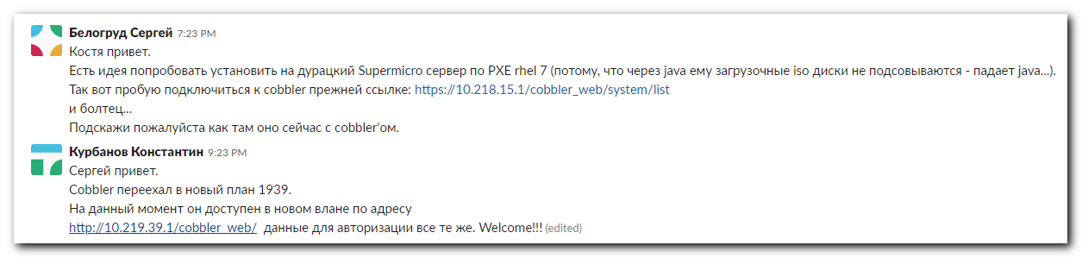

https://10.218.15.1/cobbler_web/system/list

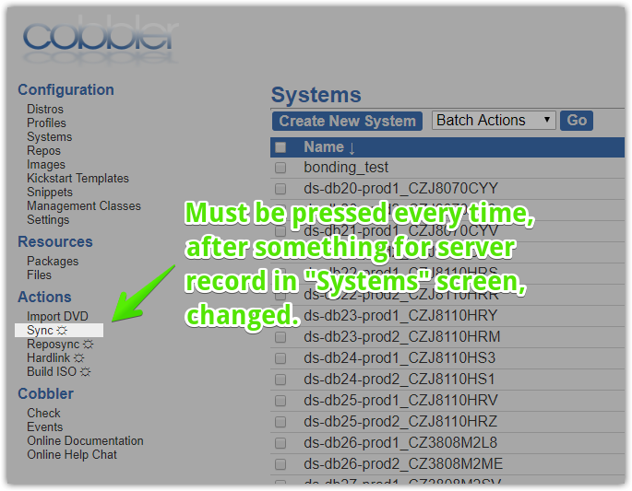

[s.belogrud@TCS4357]# scp /drives/e/data/distributives/linux/ubuntu/ubuntu-16.04-server-amd64.iso root@vm-pxe01p:/tmp/
Warning: Permanently added 'vm-pxe01p' (ECDSA) to the list of known hosts.
root@vm-pxe01p's password:
ubuntu-16.04-server-amd64.iso 100% 655MB 23.4MB/s 00:28
[s.belogrud@TCS4357]#

[root@vm-pxe01p ~]# mkdir /mnt/iso
[root@vm-pxe01p ~]# mount -o loop /tmp/ubuntu-16.04-server-amd64.iso /mnt/iso
mount: /dev/loop0 is write-protected, mounting read-only
[root@vm-pxe01p ~]# cobbler import --name=ubuntu-16.04-server-amd64 --path /mnt/iso --breed=ubuntu --arch=x86_64 --os-version="Xenial Xerus"
task started: 2018-06-21_185750_import
task started (id=Media import, time=Thu Jun 21 18:57:50 2018)
No signature matched in /var/www/cobbler/ks_mirror/ubuntu-16.04-server-amd64-x86_64
!!! TASK FAILED !!!
[root@vm-pxe01p ~]#

#
# https://www.shaunos.com/535.html
# import Ubuntu 16.04 image into cobbler
#

# Read article.
# Test follow section. It’s same as in the article.
#
[root@vm-pxe01p ~]# vim /var/lib/cobbler/distro_signatures.json
...
"xenial": {
"signatures":["dists", ".disk"],
"version_file":"Release|mini-info",
"version_file_regex":"Codename: xenial|Ubuntu 16.04",
"kernel_arch":"linux-headers-(.*)\\.deb",
"kernel_arch_regex":null,
"supported_arches":["i386","amd64"],
"supported_repo_breeds":["apt"],
"kernel_file":"linux(.*)",
"initrd_file":"initrd(.*)\\.gz",
"isolinux_ok":false,
"default_kickstart":"/var/lib/cobbler/kickstarts/sample.seed",
"kernel_options":"",
"kernel_options_post":"",
"boot_files":[]
},
...

#
# Only follow command was successful.
# I think --arch=x86_64 was wrong option and probable --os-version too.
#
[root@vm-pxe01p ~]# cobbler import --name=ubuntu-16.04-server-amd64 --path /mnt/iso --breed=ubuntu
task started: 2018-06-21_190507_import
task started (id=Media import, time=Thu Jun 21 19:05:07 2018)
Found a candidate signature: breed=ubuntu, version=precise
running: /usr/bin/file /var/www/cobbler/ks_mirror/ubuntu-16.04-server-amd64/dists/xenial/Release
received on stdout: /var/www/cobbler/ks_mirror/ubuntu-16.04-server-amd64/dists/xenial/Release: ASCII text

received on stderr:
running: /usr/bin/file /var/www/cobbler/ks_mirror/ubuntu-16.04-server-amd64/dists/xenial/Release.gpg
received on stdout: /var/www/cobbler/ks_mirror/ubuntu-16.04-server-amd64/dists/xenial/Release.gpg: PGP signature
...
received on stderr:
running: /usr/bin/file /var/www/cobbler/ks_mirror/ubuntu-16.04-server-amd64/dists/xenial/main/binary-amd64/Release
received on stdout: /var/www/cobbler/ks_mirror/ubuntu-16.04-server-amd64/dists/xenial/main/binary-amd64/Release: ASCII text

received on stderr:
running: /usr/bin/file /var/www/cobbler/ks_mirror/ubuntu-16.04-server-amd64/dists/xenial/main/binary-i386/Release
received on stdout: /var/www/cobbler/ks_mirror/ubuntu-16.04-server-amd64/dists/xenial/main/binary-i386/Release: ASCII text

received on stderr:
Found a candidate signature: breed=ubuntu, version=xenial
running: /usr/bin/file /var/www/cobbler/ks_mirror/ubuntu-16.04-server-amd64/dists/xenial/Release
received on stdout: /var/www/cobbler/ks_mirror/ubuntu-16.04-server-amd64/dists/xenial/Release: ASCII text

received on stderr:
Found a matching signature: breed=ubuntu, version=xenial
Adding distros from path /var/www/cobbler/ks_mirror/ubuntu-16.04-server-amd64:
creating new distro: ubuntu-16.04-server-x86_64
trying symlink: /var/www/cobbler/ks_mirror/ubuntu-16.04-server-amd64 -> /var/www/cobbler/links/ubuntu-16.04-server-x86_64
creating new profile: ubuntu-16.04-server-x86_64
associating repos
checking for apt repo(s)
adding apt repo for ubuntu-16.04-server-x86_64
Added repos for ubuntu-16.04-server-x86_64
*** TASK COMPLETE ***
[root@vm-pxe01p ~]#

[root@vm-pxe01p ~]# umount /mnt/iso
[root@vm-pxe01p ~]#

[root@vm-pxe01p ~]# rm /tmp/ubuntu-16.04-server-amd64.iso
rm: remove regular file ‘/tmp/ubuntu-16.04-server-amd64.iso’? y
[root@vm-pxe01p ~]#

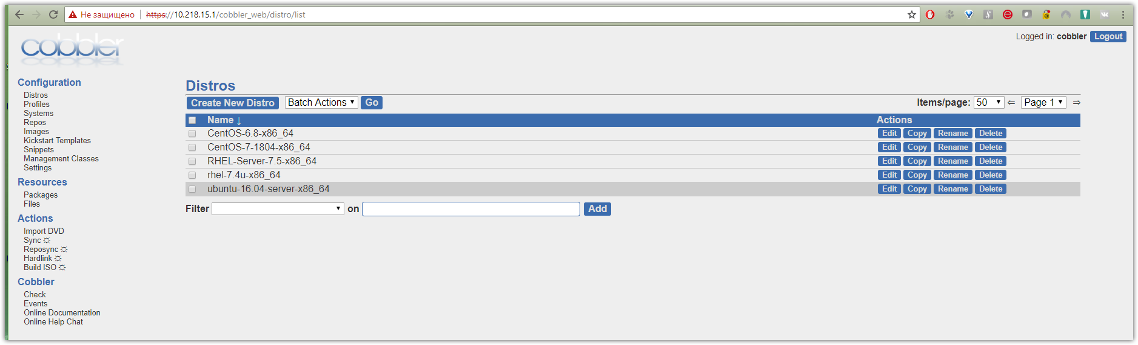

#
# Cobbler documentations.
#
http://cobbler.github.io/

# How to add iso-image.
http://cobbler.github.io/manuals/2.8.0/3/2/4_-_Import.html

#
# Cobbler host.
#
[s.belogrud@TCS4357]# host vm-pxe01p.tcsbank.ru.
vm-pxe01p.tcsbank.ru has address 10.218.15.1

From: Aleksandrov Aleksey Valerievich
Sent: Tuesday, May 8, 2018 5:30 PM
To: unix-admins <unix-admins@tinkoff.ru>
Subject: Реквизиты доступа к Cobbler

https://10.218.15.1/cobbler_web
*** / ***

Имеющиеся наработки просьба не ломать 😊 Это Джета.

--
Алексей Александров

From: Aleksandrov Aleksey Valerievich
Sent: Thursday, June 21, 2018 5:01 PM
To: Belogrud Sergey Vladimirovich <s.belogrud@tinkoff.ru>
Subject: Re: Реквизиты доступа к Cobbler

Здравствуйте!

Я делал так:

1. Заходил по SSH
2. Заливал ISO
3. Монтировал его в
$ mount /dev/cdrom /path/to/distro
4. Импортировал в Cobber
$ cobbler import --path=/path/to/distro —name=RHEL7x

Инфа есть в документации
http://cobbler.github.io/manuals/2.8.0/3/2/4_-_Import.html

Алексей Александров
Старший администратор
Тел.: +7 495 648-10-00, доб. 2138

https://stackoverflow.com/questions/41019586/which-packages-required-for-generic-ubuntu-16-04-installation

Which packages required for generic ubuntu 16.04 installation?

I want to configure cobbler for Ubuntu 16.04 installation, run cobbler reposync which calls command like

/usr/bin/debmirror --nocleanup --verbose --ignore-release-gpg --method=http --host=archive.ubuntu.com --root=/ubuntu --dist=xenial,xenial-updates,xenial-security --section=main,universe /var/www/cobbler/repo_mirror/ubuntu-16.04-x86_64 --nosource -a amd64
there are to many packages. much of them i will never use The main problem that I am required to move it between servers, and I'm looking for way for don't copy this 20G.

Which the simplest way for gathering list of packages which requirement for generic Ubuntu 16.04 installation?

The simplest way to get all requirement packages for installation the copy packages from installation disk ^)

I didn't figure out how to decrease number of packages which downloaded which cobbler's repo creating, so I just created local repo and added into it a couple of mine packages.

so, for offline ubuntu installation:
1. copy packages from installation ISO
2. add your additional packages
3. create your local repo
4. add your repo in cobbler snippets ( preseed file) for using it during installation

https://help.ubuntu.com/community/Cobbler

Cobbler

Содержание
- Introduction
- Documentation
- Notes

Introduction
Ubuntu uses cobbler as the preferred provisioning server for Ubuntu machines. Cobbler can be used to deploy Ubuntu Server for both, bare-metal machines and Virtual Machines. PXE Booting is the method used to deploy Ubuntu Server in bare-metal. Virtual Machines can be deployed both with PXE booting, and with koan, which is part of cobbler.

Documentation
- Installation - Installation and removal of cobbler
- Importing - Importing Ubuntu ISO's.
- Deployment - Deployment using both PXE and koan.
- Preseeds - Using and changing preseed files.

Notes

https://help.ubuntu.com/community/Cobbler/Import

Cobbler/Import

Содержание
- Importing Ubuntu ISO's
- Importing Ubuntu Server/Alternate ISO's
- Importing Ubuntu Mini ISO's

Importing Ubuntu ISO's
Once cobbler is installed, we can proceed with importing Ubuntu ISO's. The ISO's that have been currently tested are:
- Ubuntu Server ISO (both amd64/i386).
- Ubuntu Alternate ISO (both amd64/i386).
- Ubuntu Mini ISO (both amd64/i386).
The command to import ISO's is:
sudo cobbler import
And some of the options we need to consider when importing Ubuntu ISO's are:
- --name: Name to be used for the imported ISO distro/profile name.
- --path: Path where the ISO to be imported has been loop mounted.
- --breed: The name of the Distribution. (i.e. ubuntu, debian, redhat, suse, etc)
- --os-version: The release of the Distribution to be imported. (i.e. natty, maverick, etc)
- --arch: The architecture of the ISO. (i.e. i386, x86_64)

Importing Ubuntu Server/Alternate ISO's
Once we download an Ubuntu Server or Alternate ISO, we need to loop mount it in order to be able to import it with cobbler. We do so as follows:
sudo mount -o loop ubuntu-server-i386.iso /mnt
Once it is mounted, we import the ISO as follows:
sudo cobbler import --name=ubuntu-server --path=/mnt --breed=ubuntu
NOTE: After importing the Ubuntu Server or Alternate ISO's, a default preseed file will be provided. This preseed will ask questions during installations requiring the interaction of an administrator. However, if you would like to perform an Installation with No Questions Asks and no interaction of the administrator, please refer to NQA Preseed.

Importing Ubuntu Mini ISO's
The process of importing an Ubuntu mini ISO is similar to importing an Ubuntu Server or Alternate ISO, however it takes a different approach. First, we need to loop mount it:
sudo mount -o loop mini.iso /mnt
Second, given that the Ubuntu Mini ISO does not contain information of itself inside it, we need to specify the Ubuntu release and architecture of the ISO that we are importing. We do this as follows:
sudo cobbler import --name=ubuntu-mini --path=/mnt --breed=ubuntu --os-version=natty --arch=i386
IMPORTANT: After importing an Ubuntu Mini ISO's, no default preseed is set. For this reason, we need to define a preseed file before been able to deploy using Mini ISO's. For this, please refer to NQA Preseed.

[s.belogrud@TCS4357]# scp /drives/e/data/distributives/linux/ubuntu/ubuntu-16.04-server-amd64.iso root@vm-pxe01p:/tmp/
Warning: Permanently added 'vm-pxe01p' (ECDSA) to the list of known hosts.
root@vm-pxe01p's password:
ubuntu-16.04-server-amd64.iso 100% 655MB 23.4MB/s 00:28
[s.belogrud@TCS4357]#

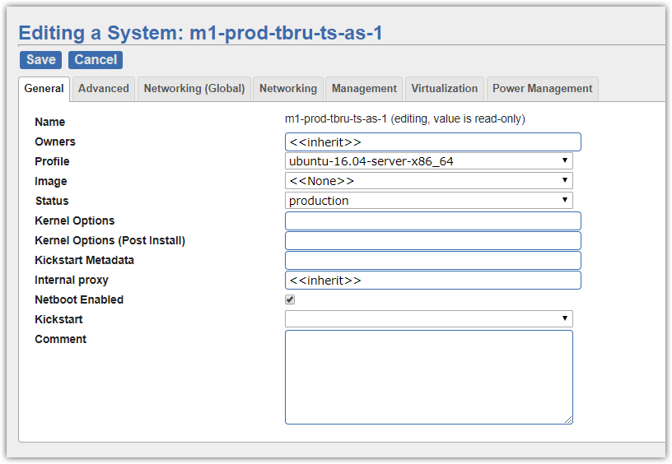
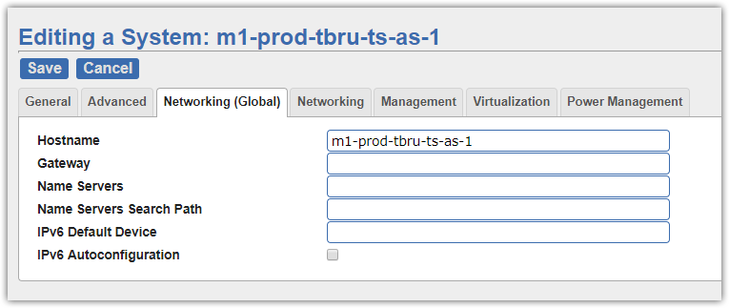
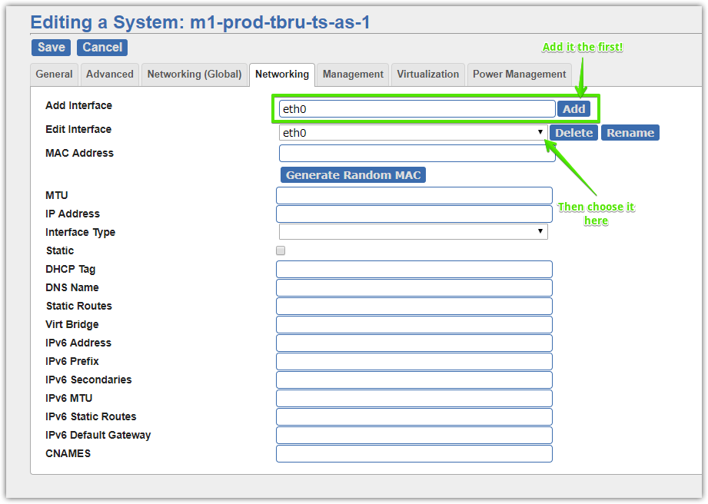

[root@vm-pxe01p ~]# grep -ie "fixed-address" /etc/dhcp/dhcpd.conf
fixed-address 10.218.15.106;
fixed-address 10.218.15.2;
fixed-address 10.218.15.107;
fixed-address 10.218.15.115;
fixed-address 10.218.15.102;
fixed-address 10.218.15.110;
fixed-address 192.168.1.100;
fixed-address 10.218.15.104;
[root@vm-pxe01p ~]#

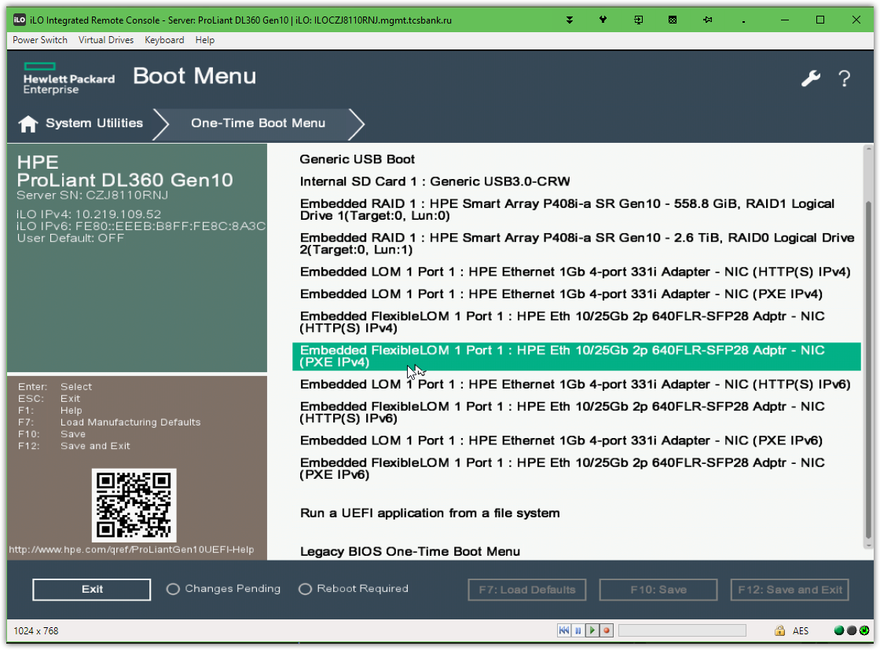

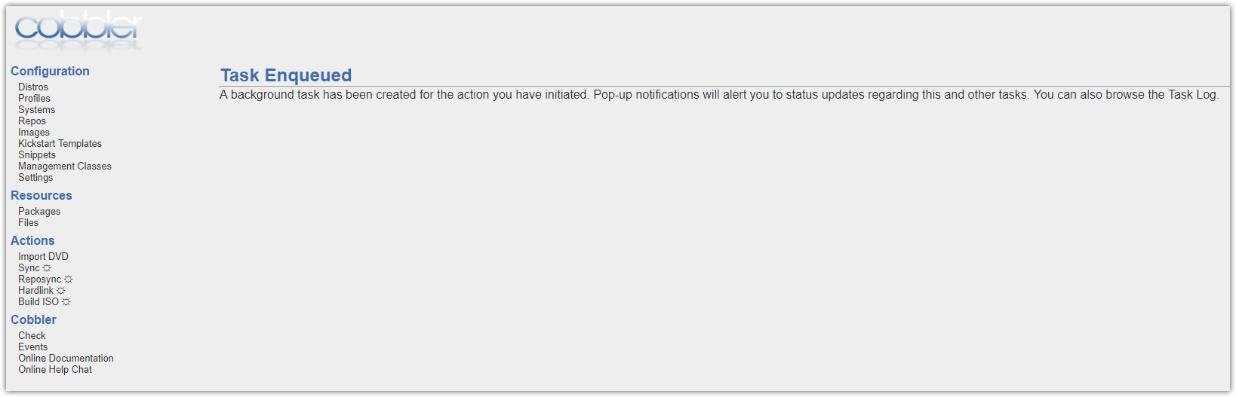

#
# If PXE not working properly, we have only follow four lines.
#
[root@vm-pxe01p ~]# tcpdump -i eth0 ether host 04:09:73:d1:e6:40
tcpdump: verbose output suppressed, use -v or -vv for full protocol decode
listening on eth0, link-type EN10MB (Ethernet), capture size 262144 bytes
15:41:37.330574 IP 0.0.0.0.bootpc > 255.255.255.255.bootps: BOOTP/DHCP, Request from 04:09:73:d1:e6:40 (oui Unknown), length 347
15:41:40.901080 IP 0.0.0.0.bootpc > 255.255.255.255.bootps: BOOTP/DHCP, Request from 04:09:73:d1:e6:40 (oui Unknown), length 347
15:41:48.900946 IP 0.0.0.0.bootpc > 255.255.255.255.bootps: BOOTP/DHCP, Request from 04:09:73:d1:e6:40 (oui Unknown), length 347
15:42:04.900713 IP 0.0.0.0.bootpc > 255.255.255.255.bootps: BOOTP/DHCP, Request from 04:09:73:d1:e6:40 (oui Unknown), length 347
...

#
# If PXE works as it should, we receive lot of packets.
#
[root@vm-pxe01p ~]# tcpdump -i eth0 ether host 04:09:73:d1:e6:40
tcpdump: verbose output suppressed, use -v or -vv for full protocol decode
listening on eth0, link-type EN10MB (Ethernet), capture size 262144 bytes
17:56:50.799941 IP 0.0.0.0.bootpc > 255.255.255.255.bootps: BOOTP/DHCP, Request from 04:09:73:d1:e6:40 (oui Unknown), length 347
17:56:54.576656 IP 0.0.0.0.bootpc > 255.255.255.255.bootps: BOOTP/DHCP, Request from 04:09:73:d1:e6:40 (oui Unknown), length 359
17:56:54.577992 ARP, Request who-has vm-pxe01p.tcsbank.ru tell 10.218.15.111, length 46
17:56:54.578014 ARP, Reply vm-pxe01p.tcsbank.ru is-at 00:50:56:98:2c:c7 (oui Unknown), length 28
17:56:54.578088 IP 10.218.15.111.rxmon > vm-pxe01p.tcsbank.ru.tftp: 51 RRQ "/grub/grub-x86_64.efi" octet tsize 0 blksize 1468
17:56:54.579015 IP vm-pxe01p.tcsbank.ru.50176 > 10.218.15.111.rxmon: UDP, length 15
17:56:54.579092 IP 10.218.15.111.rxmon > vm-pxe01p.tcsbank.ru.50176: UDP, length 30
17:56:54.581809 IP 10.218.15.111.sti-envision > vm-pxe01p.tcsbank.ru.tftp: 43 RRQ "/grub/grub-x86_64.efi" octet blksize 1468
17:56:54.595107 IP vm-pxe01p.tcsbank.ru.55754 > 10.218.15.111.sti-envision: UDP, length 516
17:56:54.595202 IP 10.218.15.111.sti-envision > vm-pxe01p.tcsbank.ru.55754: UDP, length 4
17:56:54.595231 IP vm-pxe01p.tcsbank.ru.55754 > 10.218.15.111.sti-envision: UDP, length 516
...

#
# 20180627
# For SD#1071512 I’ve tried to prepare two servers with Ubuntu 16.04.
# But I couldn’t do it with cobbler.
#
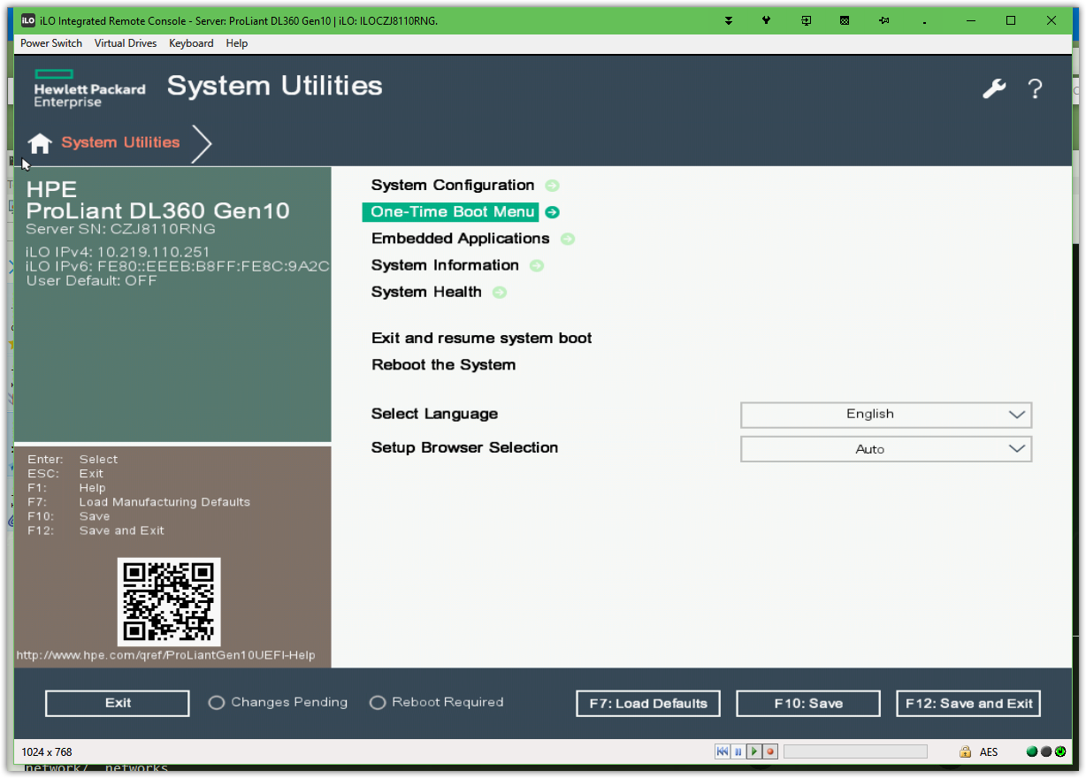

# Only this screen I get… and nothing more.
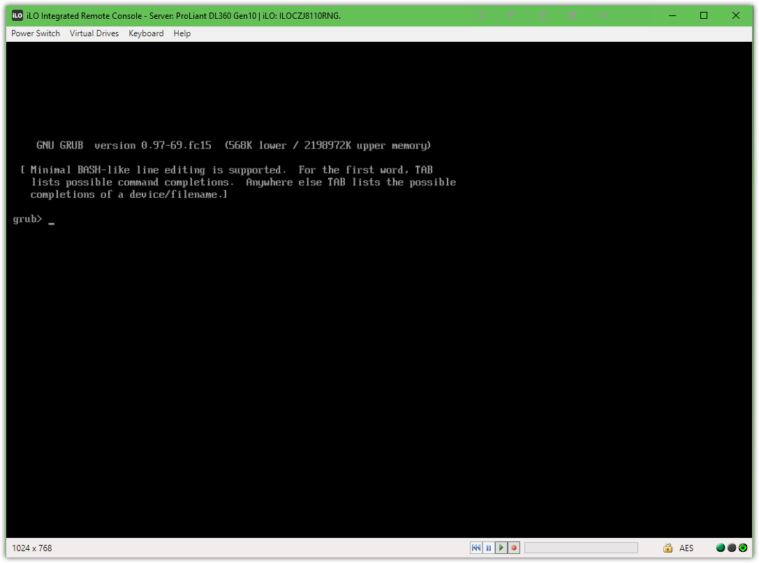

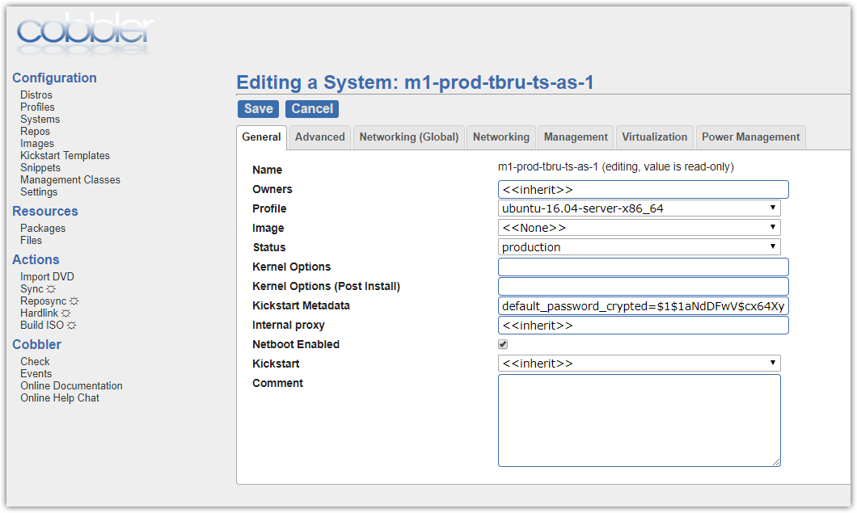
default_password_crypted=$1$1aNdDFwV$cx64XyOPJHJRJEl61hVe00

